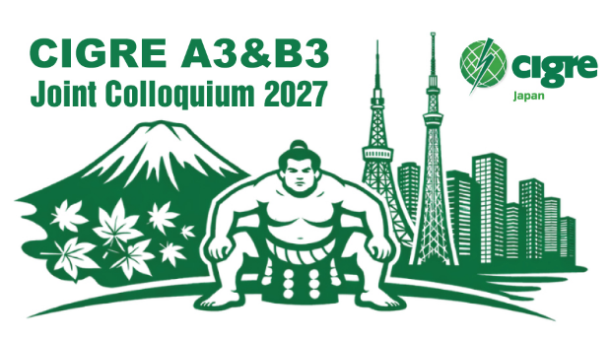

A3&B3 Joint Colloquium 2027

PSx paste here the appropriate preferential subject from the list in the instructiuon at the bottom of this document .
Information available on the Call for Papers and from your National Committee.

Type here the title of your synopsis
Times New Roman size 14

Authorship: (Times New Roman, bold, size 12), main author with an asterisk, center-aligned
John DOE* | John DOE | John DOE | John DOE
Company/University | Company/University | Company/University | Company/University
Country | Country | Country | Country
Email address | Email address | Email address | Email address

- Delete red characters before publication -

The synopsis should include Preferential subjects, Title, Authors’ names, Affiliation(s), email address of the corresponding author before the main text, and must be submitted on the website. The synopsis should provide a thorough overview of the planned oral presentation.
It should include:
- Background and objectives of the presentation,
- The main points of the presentation, including its originality, practicality, and valuable insights it offers.
Figures or tables may be included to help the audience understand the content.
Length and format:
- Recommended length: a minimum of two pages and a maximum of four pages
to achieve both higher-quality discussion and lower barrier to participation in this colloquium,
- Synopses including commercial or promotional information will be rejected,
- Font: 12-point Times New Roman.

Preferential subjects (select the most appropriate one and paste it at the top of the document)
PS1: Enhancing resilience of substations and T&D equipment under extreme environmental and natural disaster conditions.
PS2: Practical deployment and operating experiences of sustainable technologies and environmentally compatible solutions for Net Zero.
PS3: Digital intelligence for asset management and knowledge transfer in substations and equipment.

